When we visit you, to protect everyone, we:

Wash our hands or use hand sanitiser

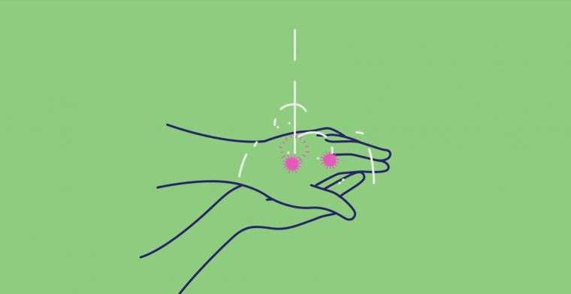

and
Physically distance where we can
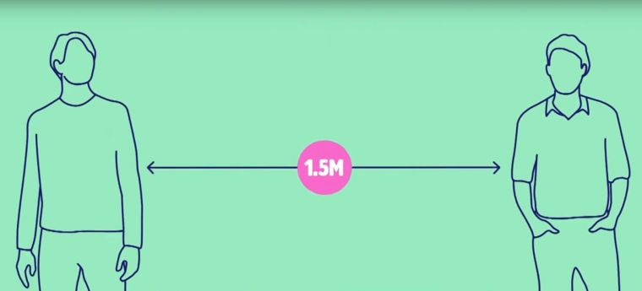

As an extra precaution we are now:
Wearing a mask

We are all in this together!

