When you visit ODH, to protect everyone, we ask you to:

Wash your hands or use hand sanitiser
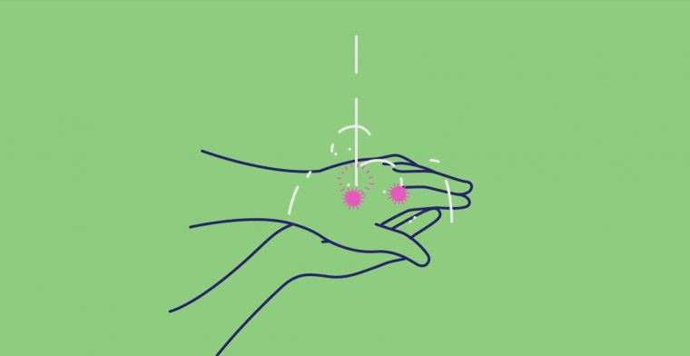

and
Physically distance
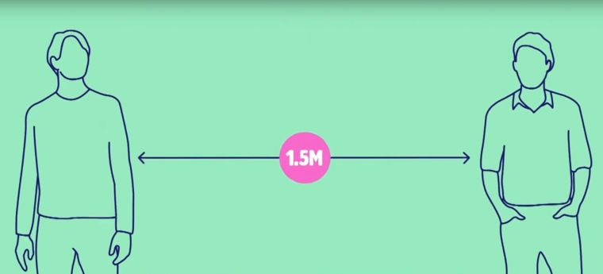

As an extra precaution we are now asking you to:
Wear a mask

We are all in this together!

